Michelle Chua
Database Schema Documentation
Sunrise and Sunset Data Warehouse
This database stores sunrise and sunset information, geographic location data, and calculated daylight metrics loaded from API responses into a PostgreSQL database.
The schema is normalized to approximately Third Normal Form (3NF) by:
- separating entities into related tables
- avoiding repeated geographic and time zone information
- storing calculated metrics separately from raw API response data
- maintaining clear one-to-many relationships

ER Diagram
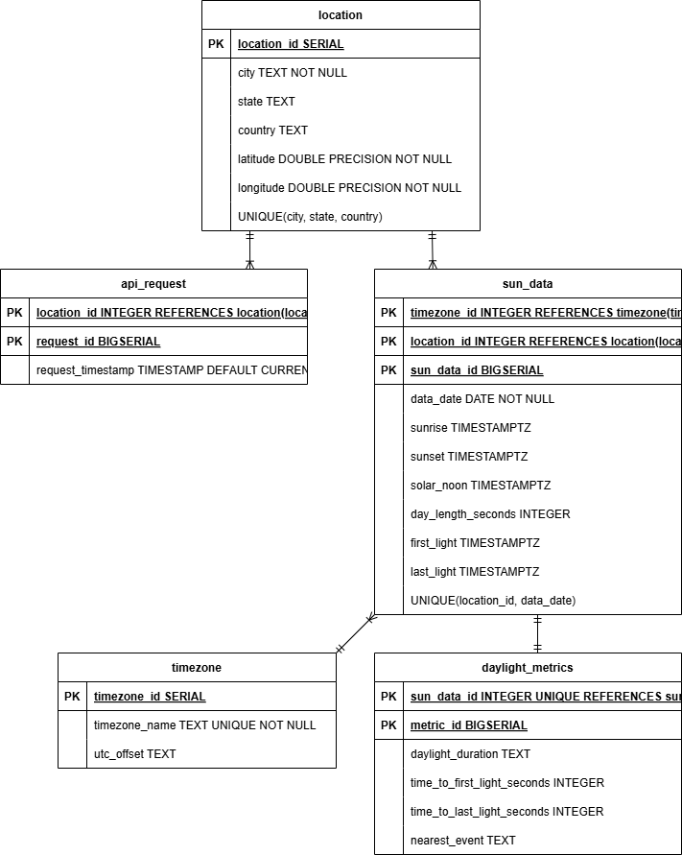

Database Overview
The database contains five tables:
- location
- api_request
- sun_data
- daylight_metrics
- timezone
Entity Relationship Summary
Table | Purpose
location | Stores geographic location and coordinates
api_request | Stores user search requests
sun_data | Stores sunrise and sunset API results
daylight_metrics | Stores calculated daylight and twilight metrics
timezone | Stores timezone information

Table Documentation
- location
Purpose
Stores unique city and geographic coordinate information.
This table prevents duplicate storage of cities and coordinates.
Example
- Clarksville, Indiana → Latitude: 38.2967, Longitude: -85.7611
- Denver, Colorado → Latitude: 39.7392, Longitude: -104.9903
Primary Key
- location_id
Relationships
- One location can relate to many API requests.
- One location can relate to many sunrise/sunset records.
- Referenced by:
  - api_request.location_id
  - sun_data.location_id
Constraints
- Unique combination of city, state, and country
Table Structure
Column name | Data type | Key | Description
location_id | INTEGER | Primary key | Unique location identifier
city | TEXT |  | City name
state | TEXT |  | State or province
country | TEXT |  | Country name
latitude | DOUBLE PRECISION |  | Geographic latitude
longitude | DOUBLE PRECISION |  | Geographic longitude

- api_request
Purpose
Stores user city search requests submitted through the application.
This table supports tracking user inputs and future analytics.
Primary Key
request_id
Foreign Keys
location_id → location.location_id
Relationships
Many requests can reference one location.
Table Structure
Column name | Data type | Key | Description
request_id | BIGSERIAL | Primary Key | Auto-generated request identifier
location_id | INTEGER | Foreign Key | Link to searched location
request_timestamp | TIMESTAMP |  | Time request was made

- sun_data
Purpose
Stores sunrise and sunset information retrieved from the Sunrise-Sunset API.
Data includes:
- sunrise time
- sunset time
- solar noon
- day length
- civil twilight times
Primary Key
sun_data_id
Foreign Keys
- location_id → location.location_id
- timezone_id → timezone.timezone_id
Relationships
- One location can have many sun data records.
- One timezone can have many sun data records.
Table Structure
Column name | Data type | Key | Description
sun_data_id | BIGSERIAL | Primary Key | Unique sunrise/sunset record
location_id | INTEGER | Foreign Key | Associated location
timezone_id | INTEGER | Foreign Key | Associated timezone
data_date | DATE |  | Date of data retrieval
sunrise | TIMESTAMP |  | Sunrise time
sunset | TIMESTAMP |  | Sunset time
solar_noon | TIMESTAMP |  | Solar noon time
day_length_seconds | INTEGER |  | Daylight duration in seconds
first_light | TIMESTAMP |  | Beginning of civil twilight
last_light | TIMESTAMP |  | End of civil twilight

- daylight_metrics
Purpose
Stores calculated daylight measurements generated during transformation.
Calculations include:
- formatted daylight duration
- time until first light
- time until last light
- nearest light event
Primary Key
metric_id
Foreign Keys
sun_data_id → sun_data.sun_data_id
Relationships
One sunrise/sunset record can have one associated metric record.
Table Structure
Column name | Data type | Key | Description
metric_id | BIGSERIAL | Primary Key | Unique metric identifier
sun_data_id | INTEGER | Foreign Key | Associated sun data record
daylight_duration | TEXT |  | Formatted HH:MM:SS duration
time_to_first_light | INTEGER |  | Time remaining until first light
time_to_last_light | INTEGER |  | Time remaining until last light
nearest_event | TEXT |  | Closest upcoming event

- timezone
Purpose
- Stores timezone information used for converting UTC timestamps into local time.
- Separating timezone information prevents duplicate timezone records.
Example
- America/New_York
- America/Chicago
- America/Los_Angeles
Primary Key
timezone_id
Relationships
One timezone can relate to many sunrise/sunset records.
Table Structure
Column name | Data type | Key | Description
timezone_id | INTEGER | Primary Key | Unique timezone identifier
timezone_name | TEXT | Unique | Timezone name
utc_offset | TEXT |  | UTC offset

Cardinality Relationships
Parent table | Child table | Relationship type
location | api_request | One-to-Many
location | sun_data | One-to-Many
timezone | sun_data | One-to-Many
sun_data | daylight_metrics | One-to-One

Normalization Notes (3NF)
This schema is normalized to approximately Third Normal Form:
- Repeating location information is separated into the location table.
- Timezone information is separated into the timezone table.
- User request information is isolated in api_request.
- Calculated metrics are separated from raw API responses in daylight_metrics.
- Non-key columns depend only on their respective primary keys.
Data Sources
Sunrise-Sunset Data Source
Data is retrieved from the Sunrise-Sunset API.
Sunrise-Sunset API Documentation
The API provides:
- sunrise time
- sunset time
- solar noon
- day length
- civil twilight information
Geocoding Data Source
Data is retrieved from a Geocoding API.
The API provides:
- city names
- latitude and longitude coordinates
- country and state information
- timezone details
Example Relationship Flow
User enters: Clarksville, IN

location
location_id = 10

↓

Sunrise-Sunset API returns:

sunrise = 6:04 AM
sunset = 8:27 PM
first_light = 5:35 AM
last_light = 8:56 PM

↓

daylight_metrics calculates:

daylight_duration = 14:23:00
time_to_last_light = 3:14:22
nearest_event = Last Light
This design prevents duplicate location and timezone information from being stored repeatedly and separates calculated values from raw API data for improved maintainability and scalability.

